Wave Energy

**Definition:**

Wave energy uses the force of the waves coming in and out in a chamber to generate electricity.

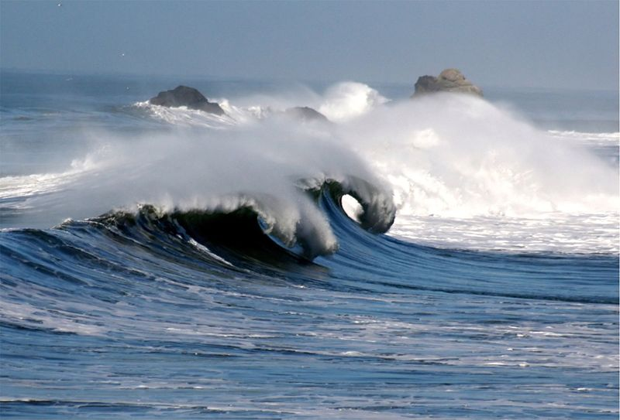

**How:**

At a wave power station, the waves arrive in the chamber and cause the water levels to rise and fall. The air produced from these movements is forced out of the holes at the top of the chamber. This air going out powers a turbine which is connected to a generator and this makes the energy.

**General Info:**

Wave energy is renewable. It is used mostly in Australia, New Zealand and countries with lots of coastline.

**Advantages and Disadvantages:**

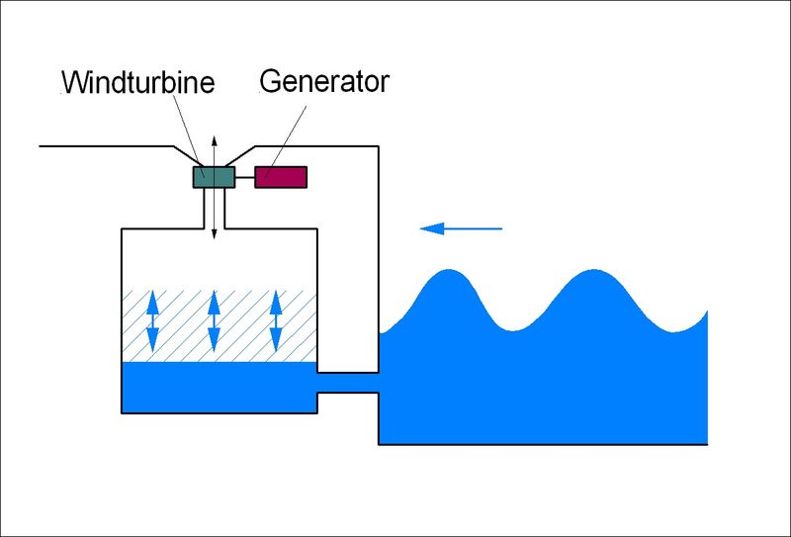Advantages are that it is free and does not produce any waste, it can produce a lot of energy and it is not expensive to operate and maintain the wave power station. Disadvantages are that there are not always waves so the energy can only be produced at certain times of the year, the process can cause harm to the ecosystems due to the building of the power station and the process is very noisy. Also, wave power stations are very expensive to build.